**ESDM Skin - Bootstrap**

The ESDM-Bootstrap skin is built using `Framework` foundation skin provided by i7media. Customization of this skin was done using [instructions from i7Media](According%20to%20https:/www.mojoportal.com/customizing-framework-with-bootswatch,%20you%20make%20the%20changes%20to%20less%20files.%20%20I7Media)

The skin uses LESS files that require compilation to CSS. There are many ways to set up Less compilation, from [command-line](http://lesscss.org/usage/index.html#command-line-usage) to [third party tools](https://github.com/gruntjs/grunt-contrib-less) to [client side compilation](http://lesscss.org/usage/#using-less-in-the-browser), but the recommended/easiest way is to use [Prepros](https://prepros.io/) (LESS GUI compliation tool).

**How to Setup Propros**

[Download Prepros](https://prepros.io/downloads)and double-click the executable to install. A little animation will show up and will disappear after some time, there is no indication that the installation is done. Prepros will now be in your Start Menu.

* Open Prepros and drag the `ESDM-Bootstrap` skin folder on top of it, this will load the project with our default settings. I would then suggest right-clicking the project name and hit "Refresh Project", sometimes it just needs a refresh to properly register to compile correctly.
* Prepros trial version is essentially free but just periodically displays a prompt message to buy which can be continually dismissed, Prepros is fully functional in trial mode.

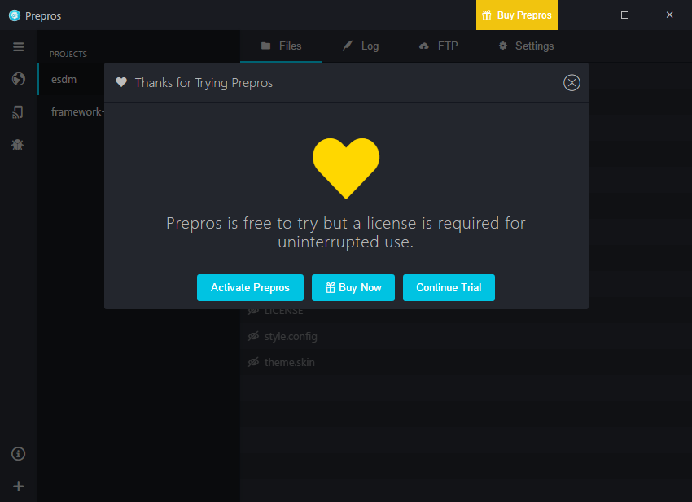

After dragging the `ESDM-Bootstrap` skin folder into Prepros, itwill load the project using the `prepros-6.config` in the skin folder root.

Essentially Prepros monitors the files for any changes in the skin folder, once a file update has been detected it will compile, the LESS files down into CSS in one file contained in css/main.css. It normally happens around 3-6 seconds after a file save and displays a toast popup in the lower left hand side of the screen

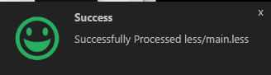

Only two less files are used in the production of the ESDM skin

* less\esdm-variables.less - Configuration of these variables will override values for them set in variables.less - n.b main.less specifies the order of import of the .less filers
* less\esdm.less – Standard CSS is allowed in a less file, we use esdm.less to put our site specific CSS

The Layout.Master remains much the same, apart from being styled using bootstrap specific styles.